**Develop The Web Application Using Node-RED**

**Aim:** Develop the web application using Node-RED

**Steps Followed:**

* Opened a Node-RED project

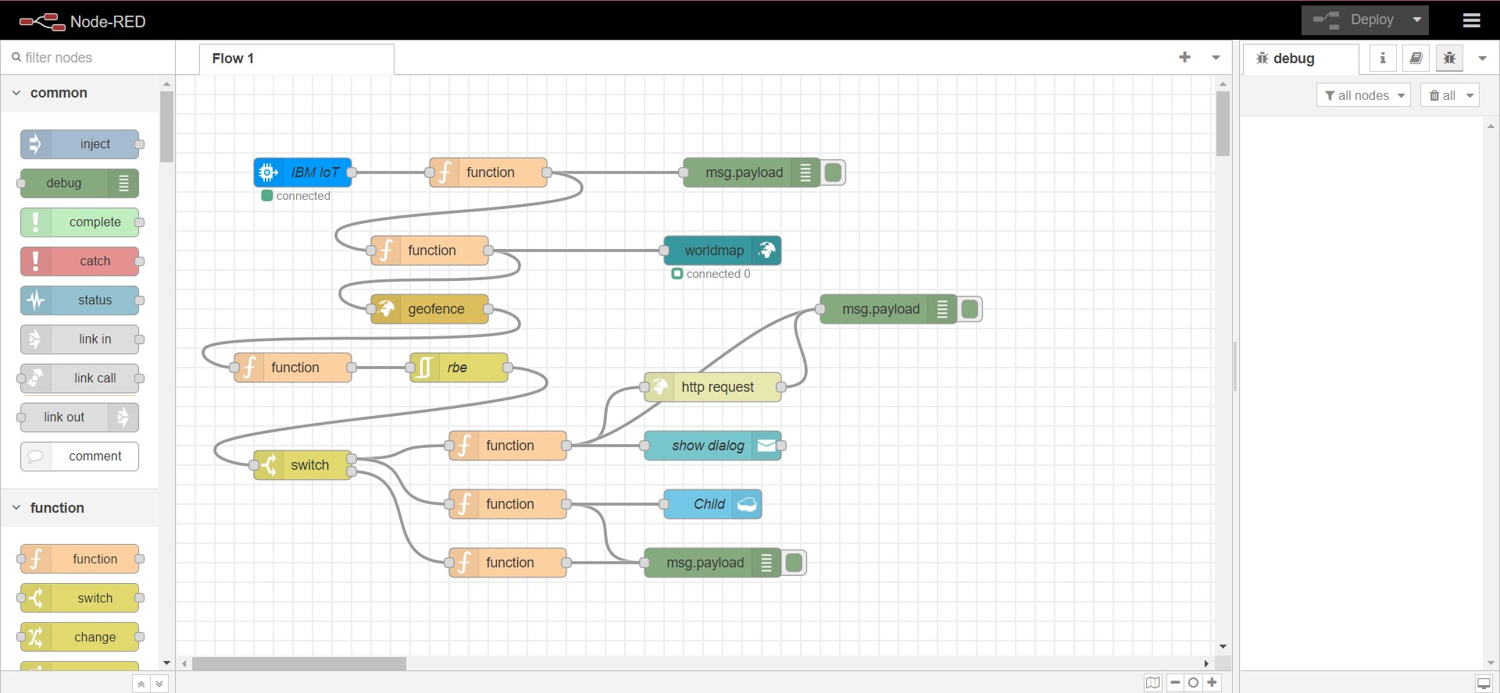

* Added code to get child location in python

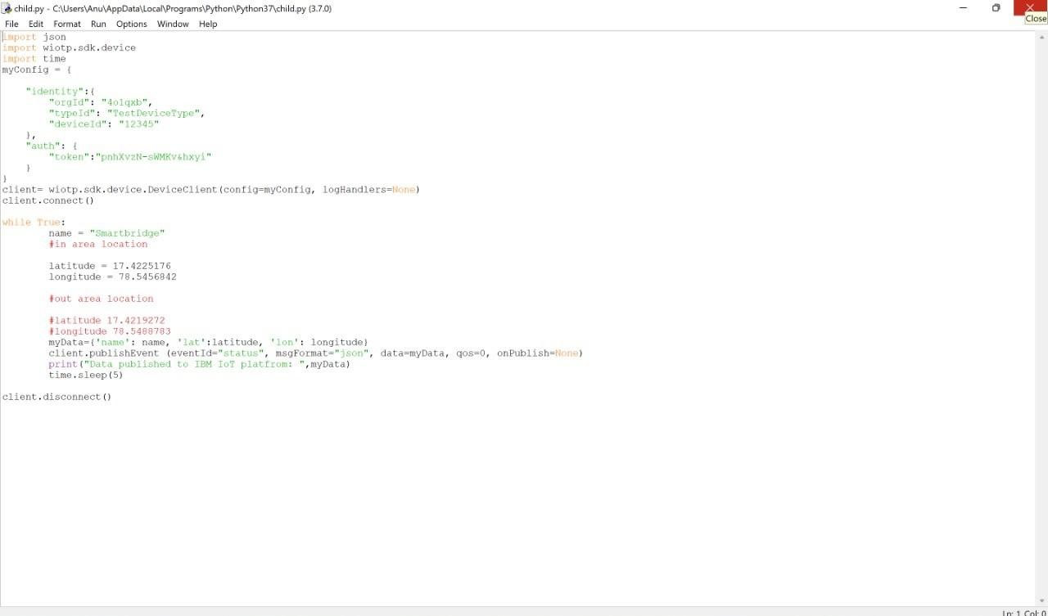

* Created the GeoFence

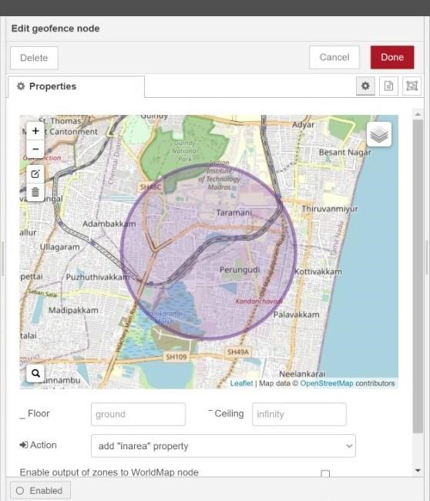

* 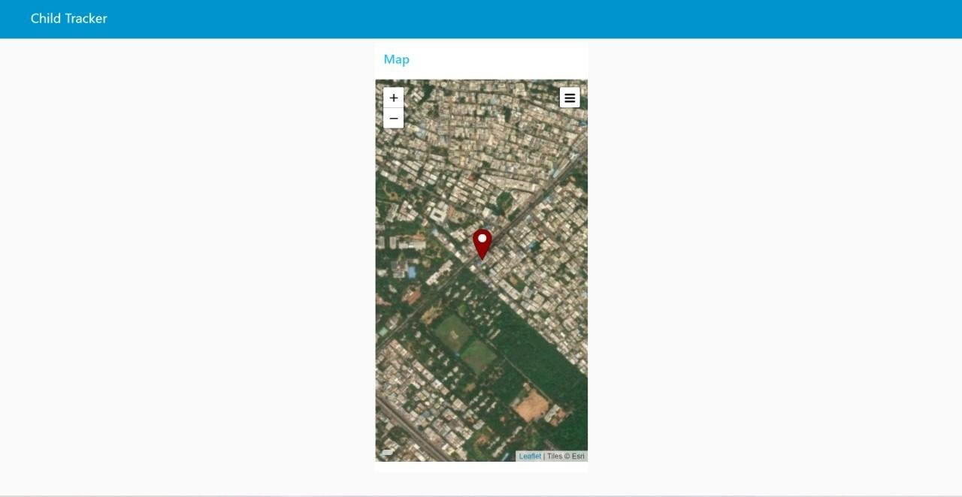Editing the HTTP Request URL

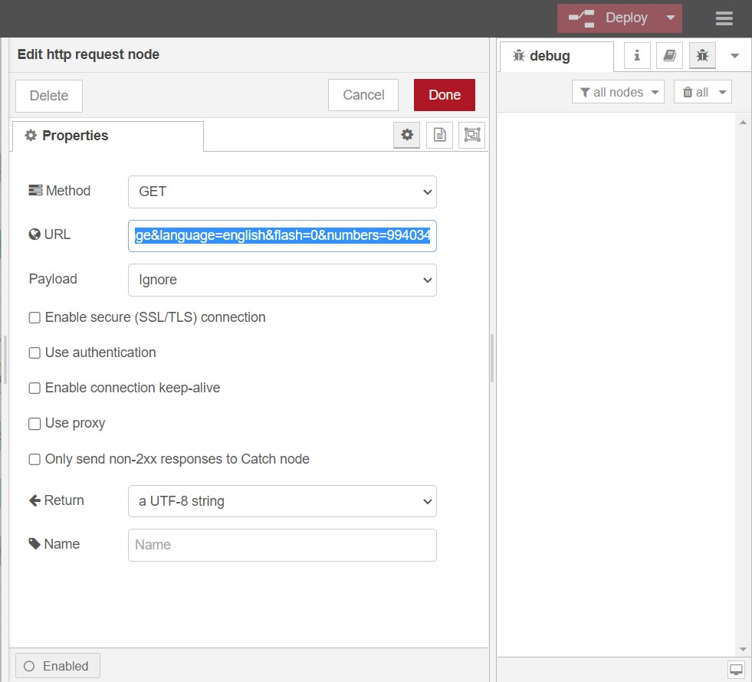

* Located the child
* Created the geofence node

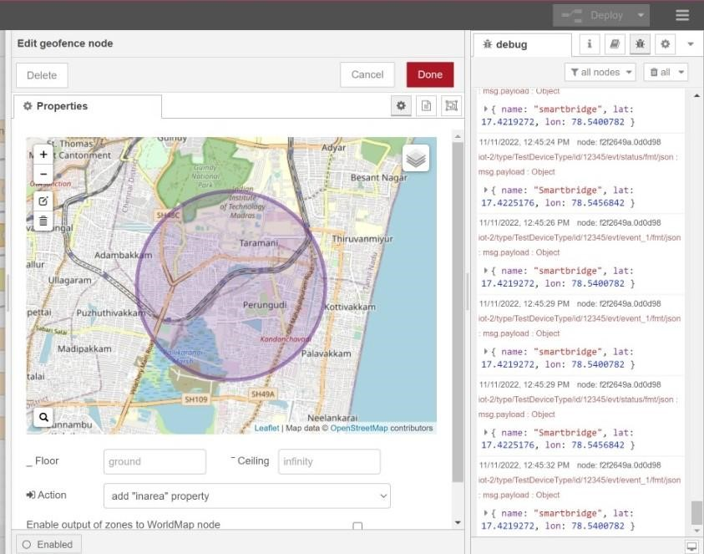

* Python script sending requests to IBM Cloud

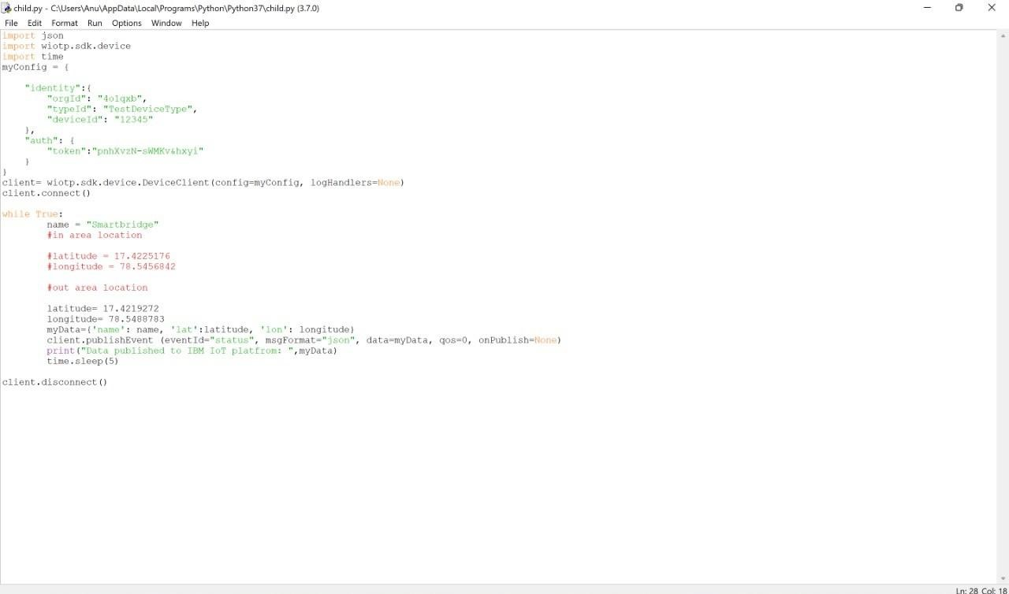

* After running the script, the web UI shows “Person is not in the particular area”

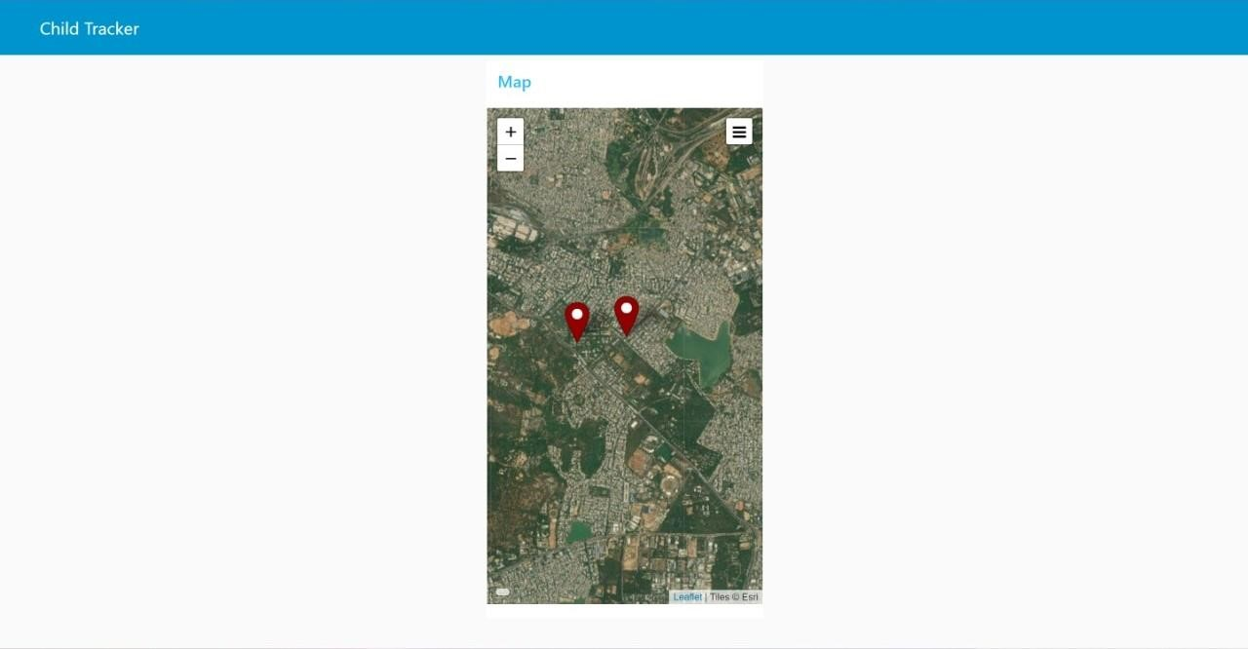

**Result:** Successfully developed the web application using Node-RED